**Amar Gajanan Mohite**

Section – IFT562

**Arizona State University**

Instructor**:** Daniel Wells

**Activity 7- Troubleshoot a VPC**

Date – 02/07/2024

At the end of task 2 you run a command to confirm the flow logs were created.  After you run the command, type your full name in the command prompt and take a screenshot of the terminal output.

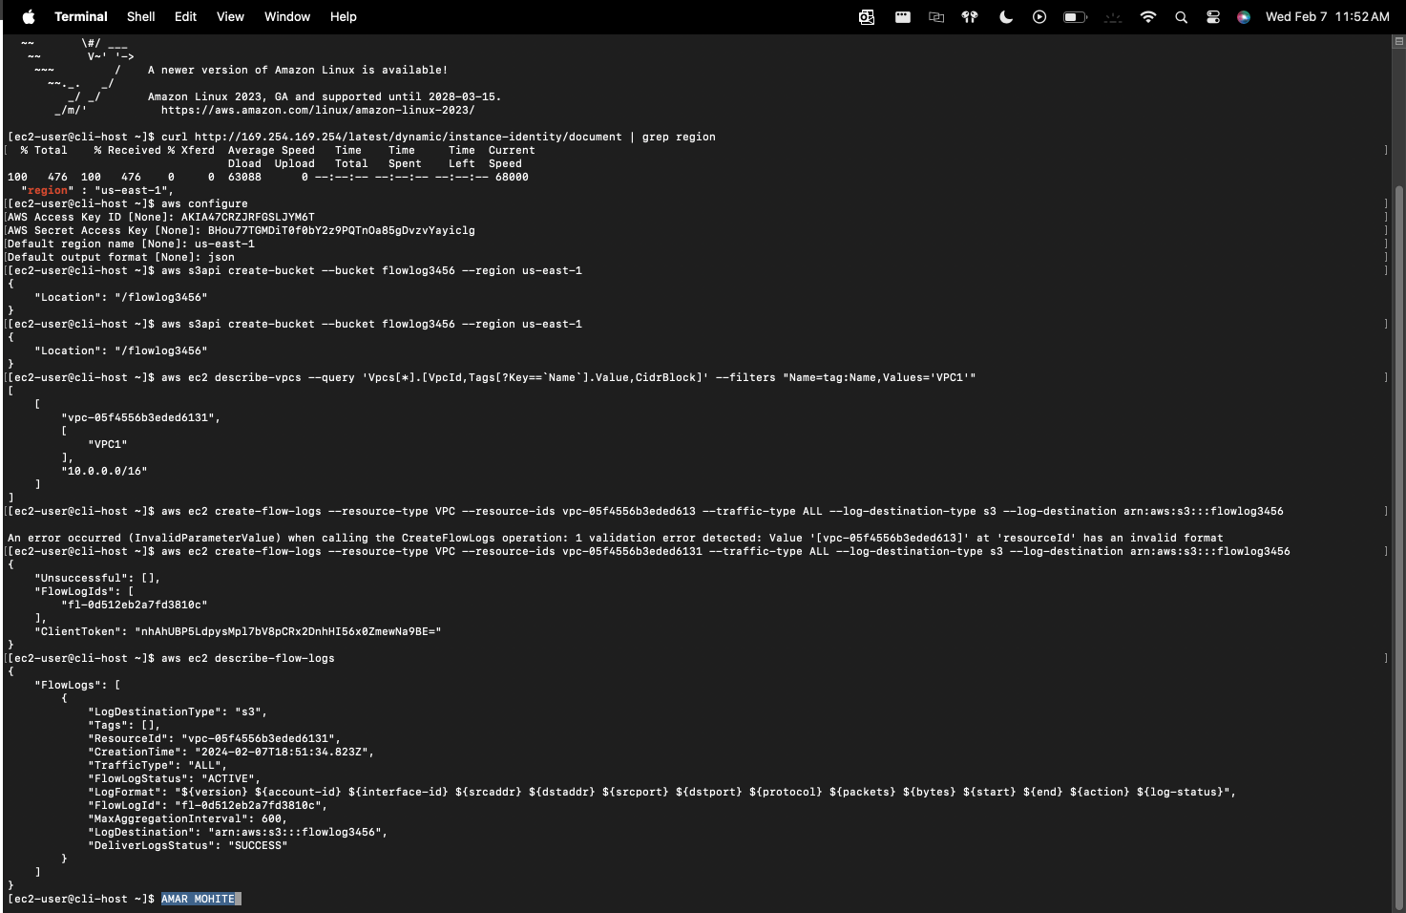

In task 3 you run a command to show the EC2 instances.  After you run the command, type your full name in the command prompt and take a screenshot of the terminal output.

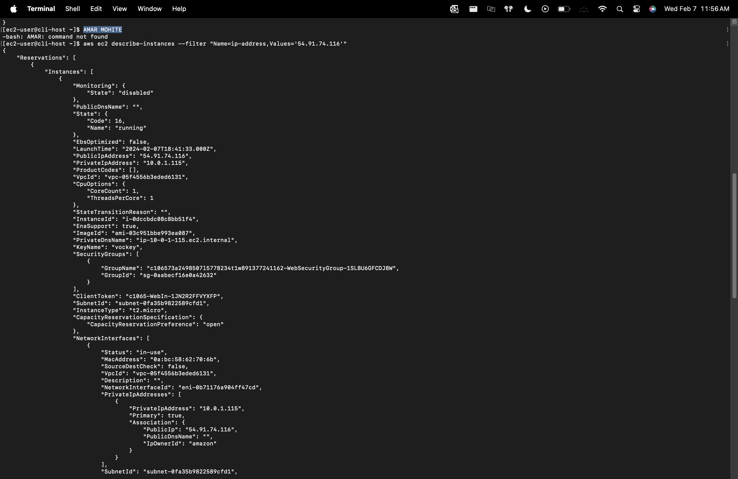

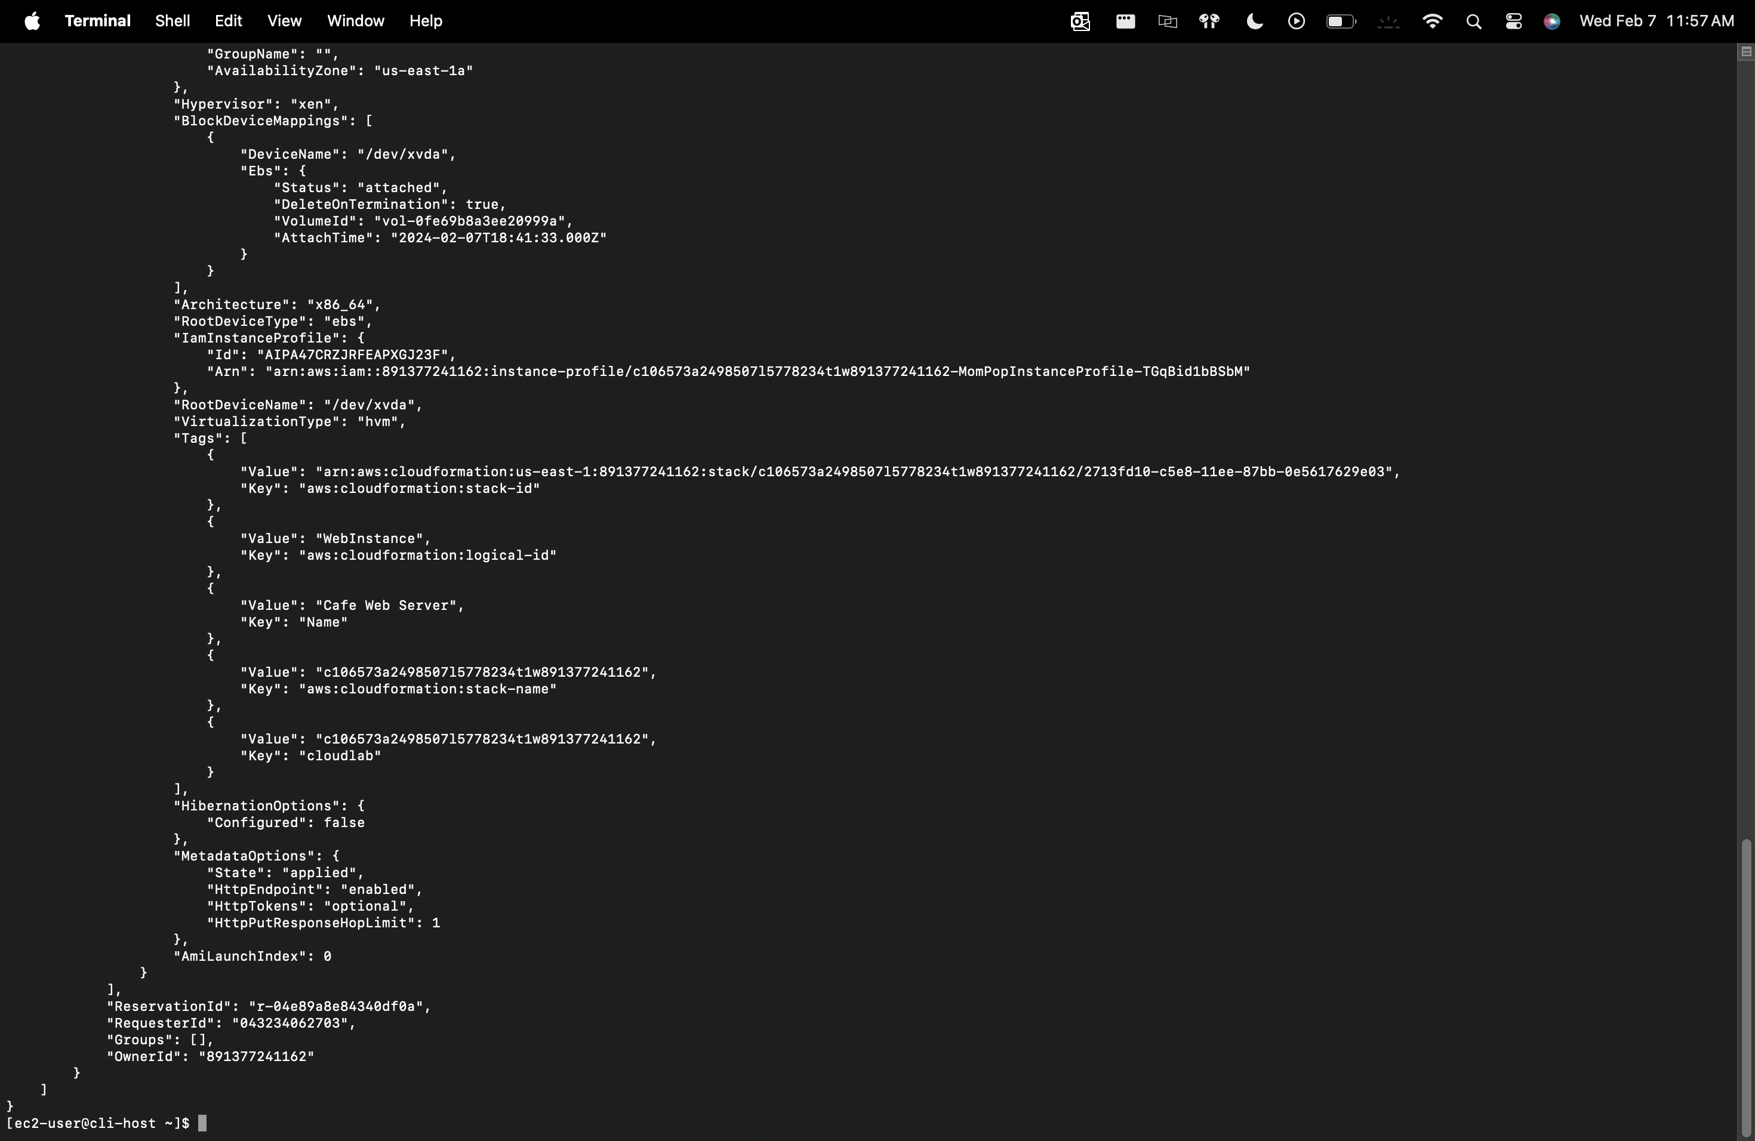

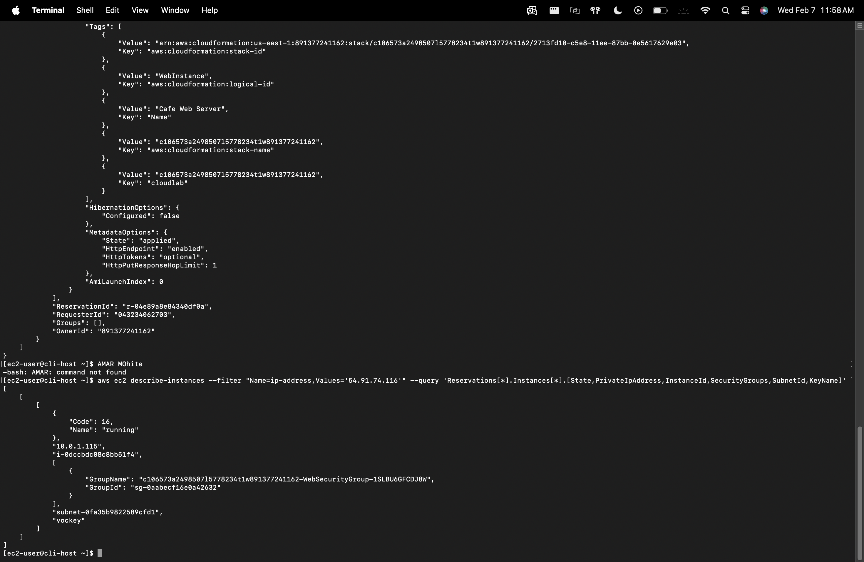

On task 4.2, after you run the describe-network-interfaces command, type your full name in the command prompt and take a screenshot of the console output.

